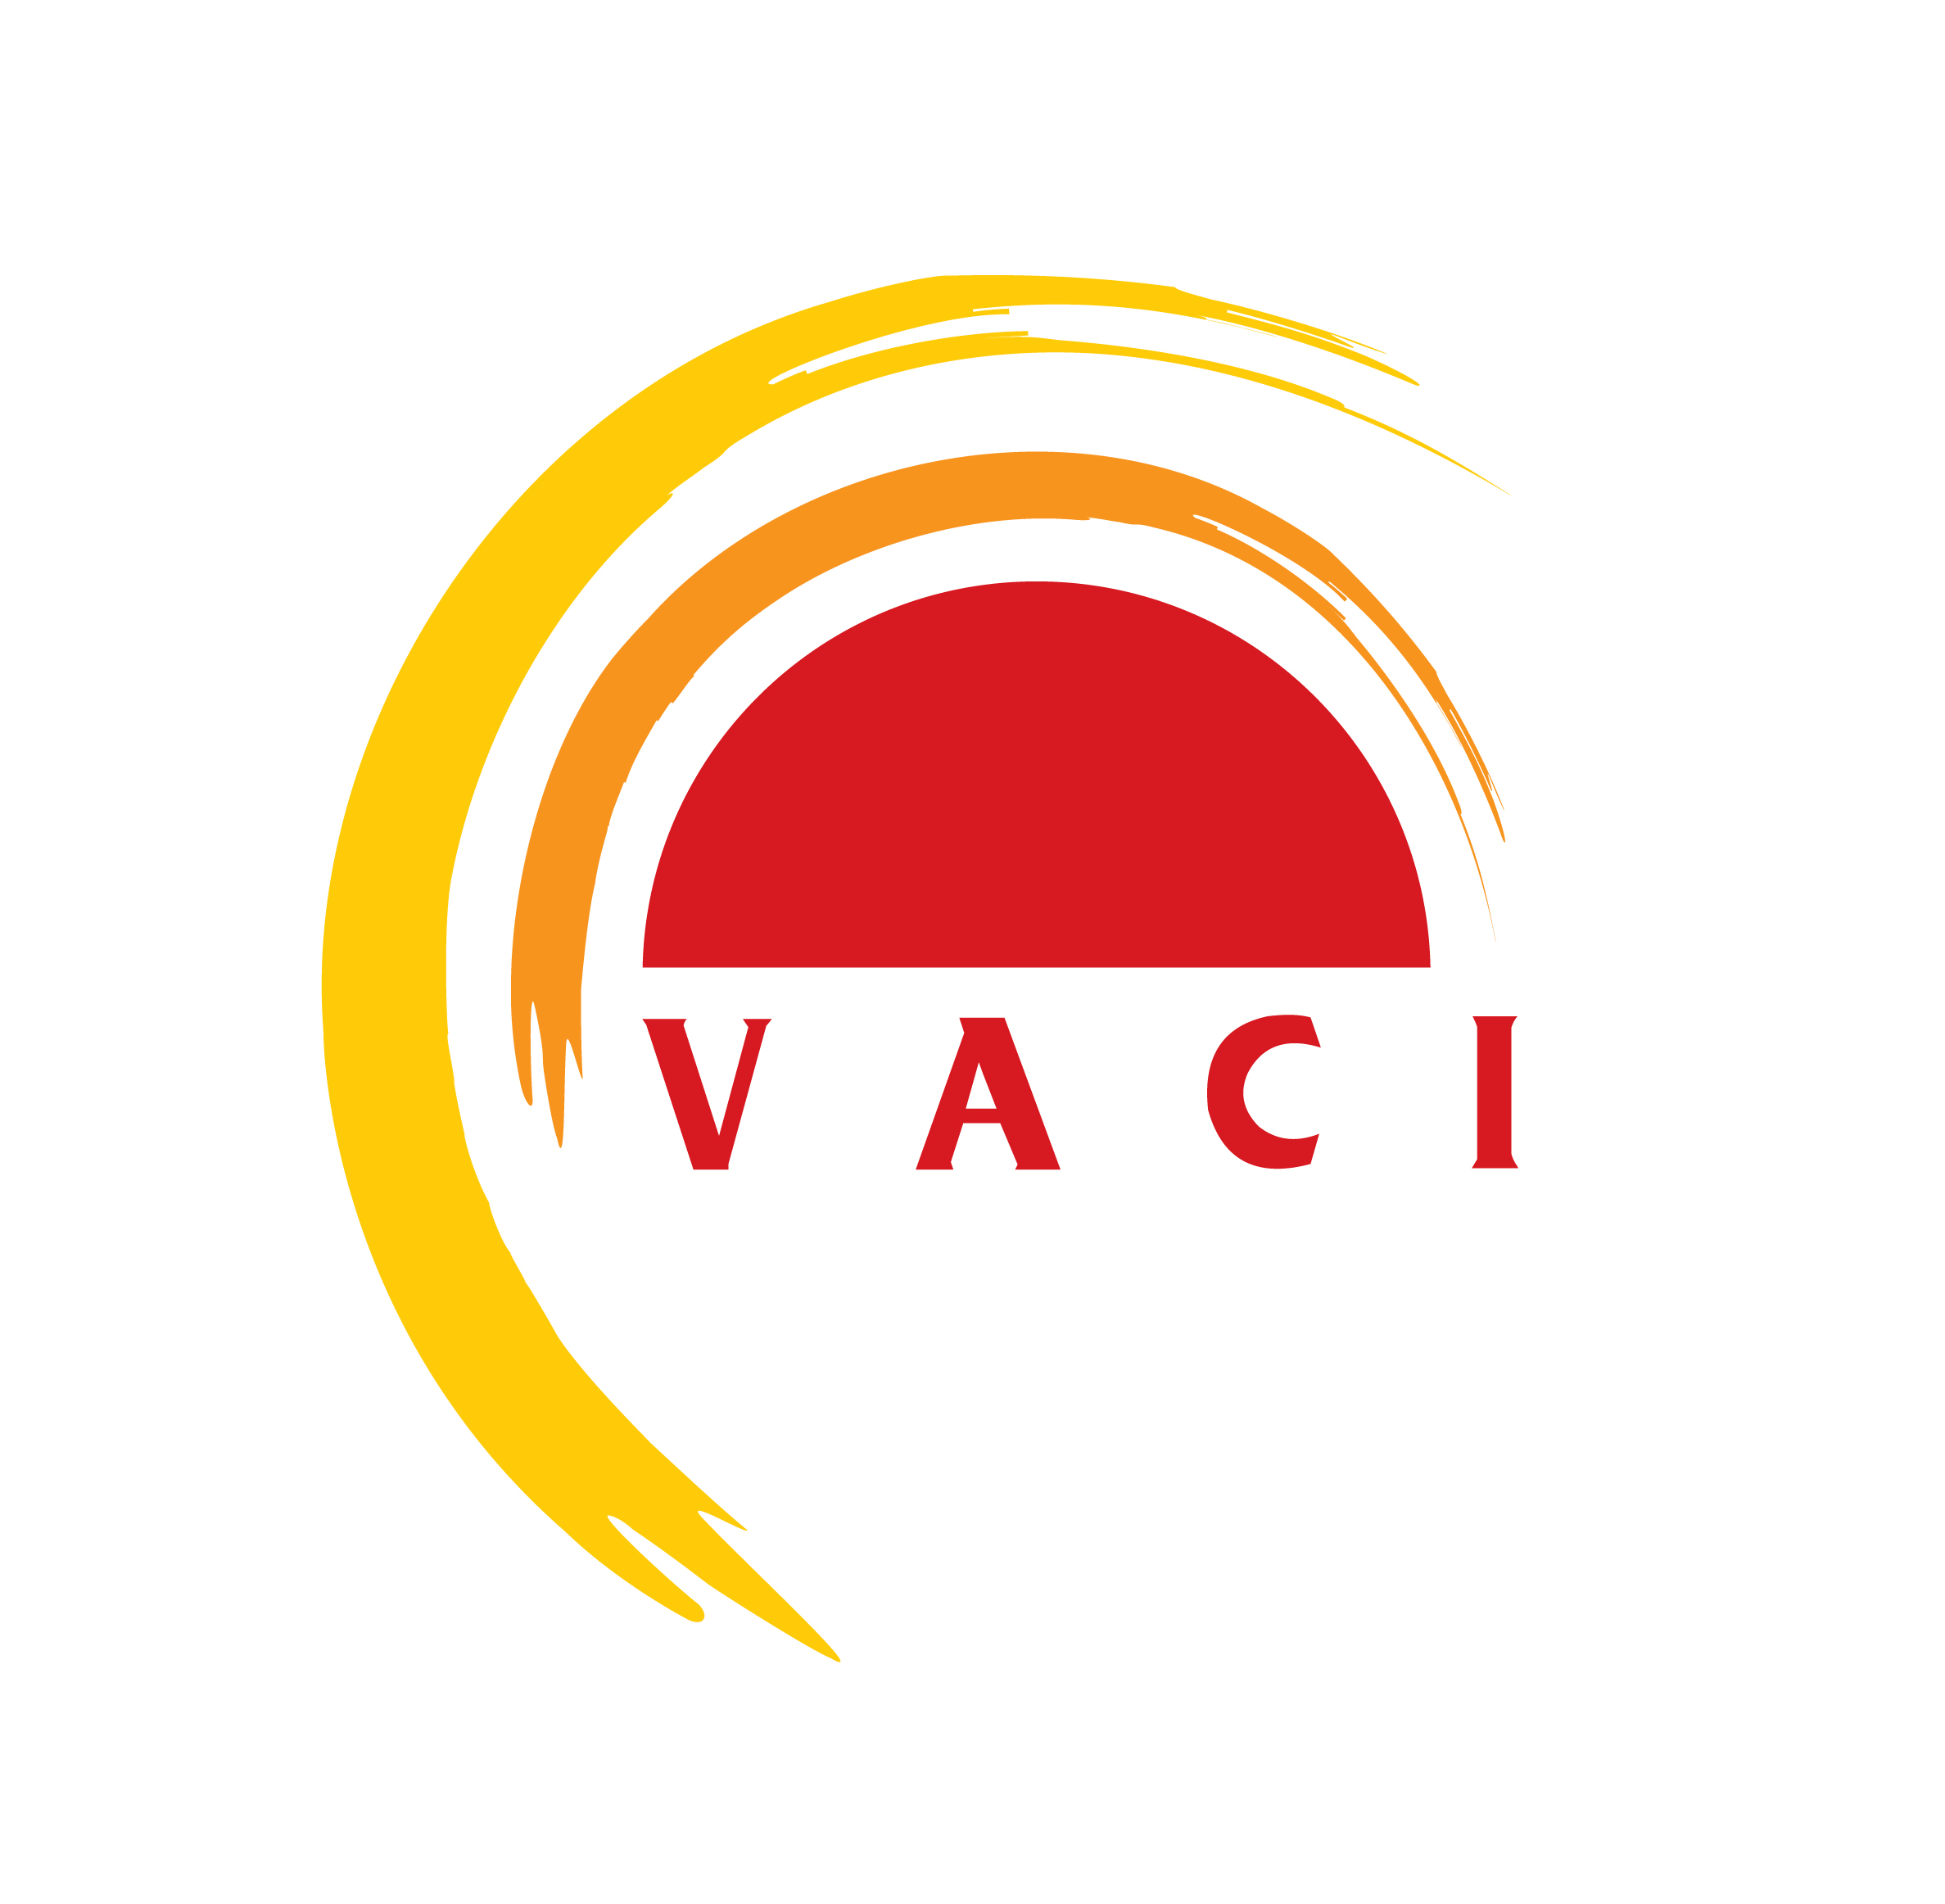

VIETNAM ANTI-CORRUPTION INITIATIVE PROGRAM
“For a Corruption-free New Day!”

GUIDELINES

VACI 2014 - “Transparency, Integrity and Accountability”

1. Introduction

The Vietnam Anti-Corruption Initiative Program (VACI) 2014, co-organized by the Government Inspectorate, the World Bank and other development partners, supports innovative ideas to minimize corruption and strengthen transparency, integrity and accountability. Its co-sponsors to date are Irish Aid and the Department for International Development (DFID-UK).

VACI identifies and directly supports through Innovation Grants small, bottom-up, innovative development proposals that deliver results. It creates opportunities for local innovators to meet, exchange ideas, share information and network with other people responding to the same concerns.

The theme for VACI 2014 is “Transparency, Integrity and Accountability”.

The program consists of two key parts:

- Innovation Competition – a jury-process competition whereby start-up funds are awarded to organizations proposing the best and feasible ideas, which meet the requirement of this competition on content, criteria and format with a view to strengthening transparency, integrity and accountability for effective anti-corruption. Winning proposals will be classified into 2 categories: (1) New initiatives; and (2) Proposals which endeavor to apply successful models of previous VACI, including (i) the Scale up of Winning proposals of previous VACI (VID 2009, VACI 2011, VACI 2013(ii) the application of models set by Organizing Committee (these models are proposed based on the implementation of previous winning proposals).

- Knowledge Exchange, inputs for policy discussion and network – is a series of activities for sharing knowledge on the legal framework for anti-corruption, current progress, practical experiences on anti-corruption as well as initiatives relating to strengthening transparency, integrity and accountability, focus on the following contents: developing a service oriented public administration, strengthening public service ethics, strengthening transparency and the right to access information and improving accountability. The activities could take place throughout the Programme.
Background:

The corruption situation in Vietnam is still serious. Petty corruption, “harassment”, and “unofficial payment” are common in many places, causing public dissatisfaction all over the country. The Party and the State of Vietnam have recognized that fighting corruption should be further accelerated and shall be the responsibility of the society as a whole. To prevent and combat corruption effectively, in addition to the efforts by the public authorities, the active participation of the community plays a very important role. In the past, the anti-corruption activities initiated by the Government of Viet Nam received fairly active participation of the general public; however, the involvement of citizens, communities and social organizations remains relatively limited in many regions and localities. One of the main causes is the fact that the role of the community in the fight against corruption has not been addressed and people are not properly aware of this role.

Vietnam has a comprehensive legal framework in place. The first Law on Anti-corruption was introduced in 2005 and amended in 2007, 2012. The UN Convention against Corruption was also ratified by Vietnam in 2009. Other legislation includes The Ordinance on Grassroots Democracy, the Law on Inspection, the Law on Complaints, the Law on Denunciations, etc. provides a solid foundation to engage in this agenda. The National Anti-corruption Strategy to 2020 includes, among various solutions and measures, specific measures to raise awareness of anti-corruption laws and policies as well as further encourage and mobilize the active participation of the society in the fight against corruption. Nevertheless, the implementation remains a problem, especially at the grassroots levels. In the current context of Vietnam, the strengthening of law implementation is crucial.

Promoting transparency, integrity and accountability is at the heart of anti-corruption agenda in Vietnam.

Vietnam Innovation Day 2009 - “More accountability and transparency, less corruption” (VID 2009) and the Vietnam Anti-Corruption Initiative Program 2011 - “Strengthening public integrity and law implementation for effective anti-corruption” (VACI 2011) were successfully co-organized by the Government Inspectorate of Vietnam and the World Bank. Vietnam Anti-Corruption Initiative Program 2013 – “More Transparency, Integrity and Accountability, Less Corruption” (VACI 2013) is in the phase of proposals’ implementation. The mentioned programs demonstrated the active participation of the community in the fight against corruption and the creative potential of organizations and entities at local levels. The events proved to be a good channel to raise awareness of the public on corruption and anti-corruption policies. These proposals have proved their effectiveness, innovation in the implementation phase, thus the scale up and replication of them are of great necessity. (See more at www.worldbank.org/vietnam and www.thanhtra.gov.vn)

With the effectiveness in encouraging the public participation in the fight against corruption brought by VID 2009, VACI 2011 and VACI 2013, the Government Inspectorate of Vietnam and the World Bank organize the next VACI Program – VACI 2014.

Some key concepts

The section below provides some key concepts with regard to the Program’s theme of “Transparency, Integrity and Accountability”.

Transparency is an especially important tool and can be used as an active measure to fight corruption. Transparency is also a demand of the public, which closely links to the rights to be informed. Transparency in public administrative management requires that people should be provided with all information not prohibited by laws in an adequate, accurate and timely manner. The Law on Anti-corruption and other legal documents has promoted public disclosure and transparency in all agencies, organizations and units. In Vietnam, the demand for public disclosure and transparency in the state apparatus in general, and in the public administrative system in particular, is increasing. Meeting this demand will help advance Vietnam’s goals of becoming a market economy with socialist orientation and a rule-of-law state of the people, by the people and for the people.

Public integrity refers to the application of ethical norms and standard behaviors in the practice of public sector agencies and organizations. In Vietnam, ethical norms and standard behaviors are not well understood and exercised by public organizations and the agencies and organizations concerned. Stimulating understanding, commitment and capacity for decision making, as well as mapping integrity-risks and identifying counter-measures, are essential for preventing corruption.

Within the framework of the program, the accountability means the obligation of the public agencies and organizations to provide information about and clarify their responsibility concerning their decisions and actions so that the citizens and the oversight institutions can understand and monitor. Accountability is a new concept and not well embraced in Vietnam yet. Facilitating the understanding and correct practice of accountability in the public and by public officials and public agencies are essential for fighting corruption in Vietnam.

People’s participation can be epitomized by the principles of ‘people know, people discuss, people do, and people supervise’. People have the right to participate in the process of including and empowering stakeholders in the decision-making process and in local activities as well as monitoring government performance that affects people's lives and their development. People’s responsibility and participation may include commenting on a policy, a legal document, a decision or an administrative act that affects their legitimate benefits and rights. The Ordinance on Grassroots Democracy, which was promulgated on April 20th, 2007 and came into effect from July 1st, 2007, aims to ensure public and social stability, protect the interests of the state, organisations and individuals and promote transparency. The Ordinance creates conditions for citizens to exercise their rights: to be informed of government activities that affect them, to discuss and contribute to the formulation of policies, to participate in local development activities, and to supervise government performance. In addition to the Ordinance on Grassroots Democracy, Decree No. 47/2007/ND-CP dated March 27, 2007 of the Government on the role and responsibility of the society in the fight against corruption paves the way for stronger and more concrete public participation in anti-corruption activities.

Public service ethics refers to the ethical values and standard behaviours applied for public servants and other authorized persons when implementing public duties. In general, ethics is a branch of philosophy which seeks to address morality. In the public sector, ethics addresses the fundamental premise of a public servant’s duty as a "steward" to the public. In other words, it is the moral justification and consideration for decisions and actions made during the completion of daily duties when working to provide the general services of government and nonprofit organizations.

Rights to access information means citizens’ rights to seek, access and use information about the operation of public agencies and other public information through legal and proactive information channel of the provider. Citizens have the right to require and propose the relevant organizations and agencies to provide information according to rule of laws.

A service oriented public administration is a democratic, clean, strong, professional and modern administration. In a service oriented public administration, the public officials have enough qualifications and capacity and the public agencies operate effectively to meet the demand of political and socio-economic development. A service oriented public administration serves the citizens and is supervised by citizens; it does not exist to be served by citizens. In other words, demand for an efficient public administration with professional and diligent public cadres which serve the needs of the general public is becoming more and more pertinent as the country has moved on to another stage of economic development, becoming a middle-income country.

Local level: village, commune, district, province or city level.

2. Competition requirements:

Requirement on content:

The proposals could focus on, but not be limited to, the following sub-themes:

(1) Strengthening public integrity and public service ethics: innovative measures to uphold ethical values of public services, responsibilities and accountabilities, cultural behaviors of public officials in the public sector; initiatives that highlight social norms and values, mapping integrity risks and deterring integrity violations of the public sector as well as measures to turn those norms and values into practices.

(2) Strengthening transparency and the right to access information: innovative ideas to improve transparency in the public procedures and public budget especially in the fields of education, healthcare, land management, natural resources extraction; measures to improve the dissemination of laws related to citizens such as laws on complaint, denunciation, civil law, etc. Innovative ideas to advance public awareness, public officials’ obligations to provide information, and to access information on policies, laws, regulations and state budget by the government as well as plans and schemes for socio-economic development of the local area.

(3) Improving Accountability: initiatives toward building a service-oriented public administration and an effective mechanism for the local government to exercise its public accountability: when, what and how government staff should be held accountable; initiatives to create systems to monitor and track public satisfaction with performance of the local government; initiatives that promote participation of active citizen, community activities or ways to improve the quality of community activities to discuss anti-corruption issues.
(4) Scale- up and replication of good models: initiatives and efforts to scale up or replicate successful pilots from VID 2009, VACI 2011 and VACI 2013. VACI organizing team has developed 3 good models on strengthening community supervision, integrating lessons on anti-corruption into current curriculum and raising awareness on integrity and anti-corruption for the youth. These models were built based on effective and successful implementation of previous winning proposals. We encourage initiatives that contextualize and adapt the models to bring effective changes to the communities.

Proposals should follow the format outlined in the application form issued by the Organizing Committee, which are available on the World Bank Vietnam’s website at http://www.worldbank.org/vn and Government Inspectorate’s website at www.thanhtra.gov.vn as well as published on Thanh Tra Newspaper.

Proposals must meet the following requirements:
- Have clear objectives, be innovative and appropriate to the main theme of the program and meet the demand of the local development process where the initiation would be implemented;
- Clearly define the expected results, together with an implementation plan over a period of not more than one year;
- Clearly define the potential beneficiaries and stake-holders during the implementation process;
- Receive support from the community for the project and attract participation by beneficiaries;
- Be realistic, sustainable and replicable;
- Have an ability to implement the proposed initiative, including the ability to mobilize human resources, working facilities and financial contributions (if possible);
- Have detailed budget estimation.

Eligibility Criteria:

The VACI 2014 is seeking proposals from all Vietnamese organizations and government units with legal status at local levels. All organizations at local levels are eligible except for the following agencies and units: (1) agencies and units affiliated with Inspectorate system at Central level (Government Inspectorate and sectoral Inspectorate units); (2) Management units of projects funded by the World Bank, (3) agencies, organizations and units affiliated with Army and Police forces. Foreign and international organizations may only apply if they are operating legitimately in Vietnam and the proposals are in partnership with a local agency recognized by the law of Vietnam. The local agency is the direct implementing agency.

Format of the application:

- All documents should be in Vietnamese and, if possible, English.
- An organization can submit more than one proposal, but one could be awarded only.
- Proposals may be submitted by post and by email. Proposals must clearly state the name and address of the proposing organization.
- In the event that two identical initiatives are received, only the first proposal submitted will be considered.

Selection Process:

All proposals will be screened by two boards of jurors comprising leading Vietnamese and international experts invited by co-organizers and co-sponsors.

The first board of jurors will select around 40 good proposals to final round. The selected proposals will be provided with comments from the jurors and guidance from independent consultants to edit and complete the proposals if needed.

From these amended proposals, the final board of jurors will select at least 20 best proposals to award and sponsor for implementing.

Winners of VID 2009, VACI 2011 and VACI 2013 are encouraged to apply for scaling-up or replication of VID/VACI-funded projects and/or to submit new initiatives. Besides, we encourage all agencies and organizations to send proposals for the application of set model. Prizes for VID 2009, VACI 2011 and VACI 2013 winners as well as application of models brought forward by Organizing Committee will not account for more than 70% of the total number of VACI 2014 prizes.

Selection Criteria:

Main selection criteria, for both new initiatives, scaling-up proposals and application of set models, include:

        - Innovation: How does the proposed initiative differ from existing approaches?
        - Results: What are the specific results and direct impacts on groups of beneficiaries that are measurable quantitatively or qualitatively?
        - Feasibility/Organizational Capacity: Does the proposal contain realistic implementation time frame and budget? Can the proposed initiative be completed within one year? What is the capacity of the organization that will implement the proposed initiative?
        - Sustainability and growth potential: Does the proposed initiative have the potential to continue or expand beyond VACI funding? How will the initiative’s results be maintained and could the initiative be replicated for other targeted groups or in other geographic areas?

Submission of proposals:

Proposals must be received by the Organizing Committee by 5:00 pm on 21 March, 2014 (the deadline is based on the date of the post-office or the time of the email) address to:

Organizing Committee of Vietnam Anti-Corruption Initiative Program (VACI) 2014
Department for International Cooperation - Government Inspectorate
D29 Tran Thai Tong St.
Cau Giay District, Hanoi
Email: giv.ic@thanhtra.gov.vn

For further information, please go to webpage: www.worldbank.org/vn or www.thanhtra.gov.vn

Or contact: Ms. Pham Thi Thanh Hien
Department for International Cooperation
Government Inspectorate
Tel: 080.48070 Fax: 080.48109
Email: thanhhien1503@gmail.com

Or Ms. Chu Thị Thúy Linh
The World Bank
Tel: (4) 39346600, ext 335
Email: lchu1@worldbank.org

Others:

- The Organizing Committee cannot be held responsible for any proposals that fail to arrive by the due date.
- The list of winning projects will be announced during the Awarding Ceremony scheduled to be held on May 2014.
- Decisions made by the boards of jurors are final.
- Submitted proposals will not be returned and the Organizing Committee reserves the right to use the any information in the proposal for communication purposes.

Awards:
- It is planned that at least 20 grants will be awarded through an open competition. The final number of winning projects will be determined by the boards of jurors based on the quality of submitted proposals and proposed budget of each finalist and the size of the award pool committed by the donors. The maximum award size is expected to be VND 300 million to support the implementation of the proposal. The final awarded amount may vary in size and will be determined based on the needs of the proposals selected.

- Short-listed proposals will be notified in early April 2014 and their representatives will be invited to attend the final competition round to be organized in May 2014 in Hanoi. The organizations selected to receive funding will be required to follow additional steps for fund disbursement.

Timeline and Key Steps:

December 9th, 2013 – March 21st, 2014: Program launching and call for proposals
Three intensive workshops for guidance to submit proposals will be organized from December 2013 to March 2014. Time, venue, and topics of these events will be informed later.

  - March 21st – April 4^{th,} 2014: Short-list round - 1st review of proposals

Proposals will be reviewed against the assessment criteria mentioned above. Finalists will be selected.

  - April 7th, 2014: Announcement of finalists
Finalists will be provided with comments from jurors and guidance from independent consultant to edit and complete the proposals (if necessary) and be invited to the VACI 2014 final round to present their ideas before a jury panel.

  - May 5th - 10th, 2014: VACI 2014 Main event - Awarding Ceremony and Knowledge Exchange, Policy Discussion and Networking activities in Hanoi.
An independent board of jurors comprised of Vietnamese and international experts invited by the organizers will evaluate each proposal and select winners to receive grants for project implementation.

