

Doing Business 2014 Fact Sheet: East Asia and the Pacific

- Fifteen of 25 economies in East Asia and the Pacific implemented at least one regulatory reform making it easier to do business in the year from June 2, 2012, to June 1, 2013—25 reforms in total.
- Since 2005, 96 percent of economies in the region have implemented business regulatory reforms in the areas measured by Doing Business. Together, the 25 economies recorded 216 reforms. Vietnam implemented the most number of reforms in the region with 21 reforms during this period, followed by China with 18.
- China is among the 20 economies worldwide that have narrowed the gap with global good practices the most since 2005. The Lao People’s Democratic Republic, Timor-Leste, Malaysia, Cambodia, and the Solomon Islands are among the top 50 narrowing this gap the most.
- Singapore has the highest global ranking on the ease of doing business, followed by Hong Kong SAR, China. New Zealand, Malaysia, and the Republic of Korea are also among the top 10.
- The Philippines is among the global top 10 improvers this year—the economies making the biggest improvement in business regulation over the past year. The government implemented regulatory reforms in three areas. The introduction of a fully operational online filing and payment system made tax compliance easier for companies. Simplified occupancy clearances eased construction permitting. And new regulations guarantee borrowers’ right to access their data in the country’s largest credit bureau.
- Data were collected for the first time this year for Myanmar. The country has the region’s lowest ranking on the ease of doing business, at 182 out of 189 economies. Challenges are particularly acute in the areas of starting a business (where it ranks at the bottom globally), enforcing contracts (where it ranks at 188), and protecting investors (where it ranks at 182).
- This year’s report features case studies highlighting the Republic of Korea’s electronic court system, Malaysia’s electronic tax filing and payment system, and Singapore’s electronic trade single window.
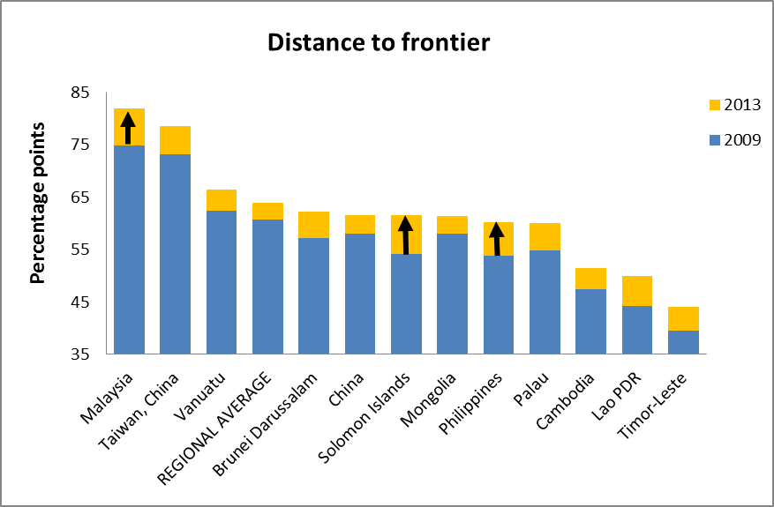
Note: The distance to frontier measure shows how far on average an economy is at a point in time from the best performance achieved by any economy on each Doing Business indicator since 2003 or the first year in which data for the indicator were collected. The measure is normalized to range between 0 and 100, with 100 representing the best performance (the frontier). The regional averages exclude Myanmar, which was added to the Doing Business sample after 2009. They also exclude Australia, Japan, the Republic of Korea, and New Zealand, which are classified as OECD high-income economies. The figure shows individual scores only for the 12 economies with the biggest improvements in the region; the arrows indicate those making the largest advances toward the frontier.
Source: Doing Business database.

Summary of 2012/13 Doing Business Reforms in East Asia and the Pacific

Australia
Australia improved its credit information system through the Privacy Amendment (Enhancing Privacy Protection) Act 2012, which permits credit bureaus to collect account payment history with improved privacy protection.
Areas of business regulatory reform: Getting credit (credit information)
DB2014 ease of doing business rank: 11
Distance to frontier in 2013 (percentage points): 80.7 (in 2012: 80.7; improvement: 0.1)

Brunei Darussalam
Brunei Darussalam improved access to credit information by establishing a public credit registry.
Areas of business regulatory reform: Getting credit (credit information)
DB2014 ease of doing business rank: 59
Distance to frontier in 2013 (percentage points): 62.1 (in 2012: 59.6; improvement: 2.5)

Cambodia
Cambodia made starting a business more difficult by introducing a requirement for a company name check at the Department of Intellectual Property and by increasing the costs both for getting registration documents approved and stamped by the Phnom Penh Tax Department and for completing incorporation with the commercial registrar.
Areas of business regulatory reform: Starting a business (making it more difficult)
DB2014 ease of doing business rank: 137
Distance to frontier in 2013 (percentage points): 51.4 (in 2012: 51.2; improvement: 0.2)

China
China improved its credit information system by introducing credit information industry regulations, which guarantee borrowers’ right to inspect their data. In addition, China made enforcing contracts easier by amending its civil procedure code to streamline and speed up all court proceedings.
Areas of business regulatory reform: Getting credit (credit information), Enforcing contracts
DB2014 ease of doing business rank: 96
Distance to frontier in 2013 (percentage points): 61.5 (in 2012: 60.2; improvement: 1.3)

Fiji
Fiji made paying taxes more complicated for companies by transferring the fringe benefit tax liability from employees to employers and by limiting the deductibility of mandatory contributions.
Areas of business regulatory reform: Paying taxes (making it more difficult)
DB2014 ease of doing business rank: 62
Distance to frontier in 2013 (percentage points): 66.8 (in 2012: 66.8; improvement: 0.0)

Hong Kong SAR, China
Hong Kong SAR, China made starting a business less costly by abolishing the capital duty levied on local companies. On the other hand, Hong Kong SAR, China made transferring property more costly by increasing the stamp duty.
Areas of business regulatory reform: Starting a business, Registering property (making it more difficult)
DB2014 ease of doing business rank: 2
Distance to frontier in 2013 (percentage points): 89.1 (in 2012: 89.7; improvement: −0.6)

Indonesia
Indonesia improved its credit information system through a new regulation setting up a legal framework for establishing credit bureaus.
Areas of business regulatory reform: Getting credit (credit information)
DB2014 ease of doing business rank: 120
Distance to frontier in 2013 (percentage points): 57.8 (in 2012: 57.7; improvement: 0.1)

Japan
DB2014 ease of doing business rank: 27
Distance to frontier in 2013 (percentage points): 78.6 (in 2012: 78.6; improvement: 0.0)

Kiribati
DB2014 ease of doing business rank: 122
Distance to frontier in 2013 (percentage points): 56.9 (in 2012: 56.9; improvement: 0.0)

Korea, Rep.
The Republic of Korea made getting credit easier by strengthening its secured transactions system through the creation of new types of security rights that can be publicized through registration.
Areas of business regulatory reform: Getting credit (legal rights)
DB2014 ease of doing business rank: 7
Distance to frontier in 2013 (percentage points): 83.7 (in 2012: 83.5; improvement: 0.2)

Lao PDR
The Lao People’s Democratic Republic made paying taxes less costly for companies by reducing the corporate income tax rate—though it also introduced a new property transfer tax.
Areas of business regulatory reform: Paying taxes
DB2014 ease of doing business rank: 159
Distance to frontier in 2013 (percentage points): 49.8 (in 2012: 49.2; improvement: 0.6)

Malaysia
Malaysia made starting a business less costly by reducing the company registration fees. And it made dealing with construction permits easier by establishing a one-stop shop. In addition, Malaysia made getting electricity easier by increasing the efficiency of internal processes at the utility and improving its communication and dialogue with contractors.
Areas of business regulatory reform: Starting a business, Dealing with construction permits, Getting electricity
DB2014 ease of doing business rank: 6
Distance to frontier in 2013 (percentage points): 81.9 (in 2012: 80.1; improvement: 1.8)

Marshall Islands
DB2014 ease of doing business rank: 114
Distance to frontier in 2013 (percentage points): 56.0 (in 2012: 55.8; improvement: 0.2)

Micronesia, Fed. Sts.
DB2014 ease of doing business rank: 156
Distance to frontier in 2013 (percentage points): 45.9 (in 2012: 48.0; improvement: −2.1)

Mongolia
Mongolia made starting a business easier by eliminating the requirement to get company statutes and charters notarized as well as the requirement to register a new company with the local tax office. And it made dealing with construction permits easier by eliminating the requirement for a technical review of the building plans by the state for low- and medium-risk construction projects. In addition, Mongolia made getting electricity easier by increasing the efficiency of the utility’s internal processes, enforcing time limits at different stages of the connection process, and eliminating the fees for testing the installation.
Areas of business regulatory reform: Starting a business, Dealing with construction permits, Getting electricity
DB2014 ease of doing business rank: 76
Distance to frontier in 2013 (percentage points): 61.4 (in 2012: 60.2; improvement: 1.2)

Myanmar
Myanmar made paying taxes less costly for companies by reducing the corporate income tax rate.
Areas of business regulatory reform: Paying taxes
DB2014 ease of doing business rank: 182
Distance to frontier in 2013 (percentage points): 42.4 (in 2012: 41.7; improvement: 0.7)

New Zealand
New Zealand made enforcing contracts easier by improving its case management system to ensure speedier and less costly adjudication of cases.
Areas of business regulatory reform: Enforcing contracts
DB2014 ease of doing business rank: 3
Distance to frontier in 2013 (percentage points): 88.6 (in 2012: 88.7; improvement: 0.0)

Palau
Palau made getting credit easier by strengthening its secured transactions system through a new law that establishes a centralized collateral registry, broadens the range of assets that can be used as collateral to include future assets, allows a general description in the security agreement of debts and obligations as well as assets pledged as collateral, establishes clear priority rules outside bankruptcy for secured creditors, and allows out-of-court enforcement of the collateral. In addition, Palau made enforcing contracts easier by introducing an electronic filing system for court users.
Areas of business regulatory reform: Getting credit (legal rights), Enforcing contracts
DB2014 ease of doing business rank: 100
Distance to frontier in 2013 (percentage points): 60.0 (in 2012: 54.8; improvement: 5.2)

Papua New Guinea
DB2014 ease of doing business rank: 113
Distance to frontier in 2013 (percentage points): 59.0 (in 2012: 59.0; improvement: 0.0)

Philippines
The Philippines made dealing with construction permits easier by eliminating the requirement to obtain a health certificate. And it improved access to credit information by beginning to distribute both positive and negative information and by enacting a data privacy act that guarantees borrowers’ right to access their data. In addition, the Philippines made paying taxes easier for companies by introducing an electronic filing and payment system for social security contributions.
Areas of business regulatory reform: Dealing with construction permits, Getting credit (credit information), Paying taxes
DB2014 ease of doing business rank: 108
Distance to frontier in 2013 (percentage points): 60.1 (in 2012: 55.1; improvement: 5.0)

Samoa
Samoa made transferring property more expensive by increasing the stamp duty.
Areas of business regulatory reform: Registering property (making it more difficult)
DB2014 ease of doing business rank: 61
Distance to frontier in 2013 (percentage points): 65.9 (in 2012: 66.2; improvement: −0.4)

Singapore
Singapore made transferring property easier by introducing an online procedure for property transfers. In addition, it improved its credit information system by guaranteeing by law borrowers’ right to inspect their own data.
Areas of business regulatory reform: Registering property, Getting credit (credit information)
DB2014 ease of doing business rank: 1
Distance to frontier in 2013 (percentage points): 92.2 (in 2012: 91.4; improvement: 0.8)

Solomon Islands
DB2014 ease of doing business rank: 97
Distance to frontier in 2013 (percentage points): 61.5 (in 2012: 61.4; improvement: 0.1)

Taiwan, China
DB2014 ease of doing business rank: 16
Distance to frontier in 2013 (percentage points): 78.6 (in 2012: 78.6; improvement: 0.0)

Thailand
Thailand made paying taxes less costly for companies by reducing employers’ social security contribution rate.
Areas of business regulatory reform: Paying taxes
DB2014 ease of doing business rank: 18
Distance to frontier in 2013 (percentage points): 75.9 (in 2012: 75.5; improvement: 0.4)

Timor-Leste
DB2014 ease of doing business rank: 172
Distance to frontier in 2013 (percentage points): 44.0 (in 2012: 44.1; improvement: 0.0)

Tonga
Tonga improved access to credit information by establishing a private credit bureau. On the other hand, it made paying taxes more complicated for companies by introducing a superannuation levy—though it also abolished the business license for 2013.
Areas of business regulatory reform: Getting credit (credit information), Paying taxes (making it more difficult)
DB2014 ease of doing business rank: 57
Distance to frontier in 2013 (percentage points): 66.5 (in 2012: 65.5; improvement: 1.0)

Vanuatu
Vanuatu improved access to credit information by establishing a private credit bureau.
Areas of business regulatory reform: Getting credit (credit information)
DB2014 ease of doing business rank: 74
Distance to frontier in 2013 (percentage points): 66.4 (in 2012: 65.1; improvement: 1.2)

Vietnam
Vietnam improved its credit information system through a decree setting up a legal framework for the establishment of private credit bureaus. In addition, it strengthened investor protections by introducing greater disclosure requirements for publicly held companies in cases of related-party transactions. On the other hand, Vietnam made paying taxes more costly for companies by increasing employers’ social security contribution rate.
Areas of business regulatory reform: Getting credit (credit information), Protecting investors, Paying taxes (making it more difficult)
DB2014 ease of doing business rank: 99
Distance to frontier in 2013 (percentage points): 61.1 (in 2012: 60.4; improvement: 0.7)

About the Doing Business report series
The joint World Bank and IFC flagship Doing Business report analyzes regulations that apply to an economy’s businesses during their life cycle, including start-up and operations, trading across borders, paying taxes, and resolving insolvency. The aggregate ease of doing business rankings are based on 10 indicators and cover 189 economies. Doing Business does not measure all aspects of the business environment that matter to firms and investors. For example, it does not measure the quality of fiscal management, other aspects of macroeconomic stability, the level of skills in the labor force, or the resilience of financial systems. Its findings have stimulated policy debates worldwide and enabled a growing body of research on how firm-level regulation relates to economic outcomes across economies. This year’s report marks the 11th edition of the global Doing Business report series and covers 189 economies. For more information about the Doing Business reports, please visit doingbusiness.org and join us on doingbusiness.org/Facebook.

About the World Bank Group
The World Bank Group is one of the world’s largest sources of funding and knowledge for developing countries. It comprises five closely associated institutions: the International Bank for Reconstruction and Development (IBRD) and the International Development Association (IDA), which together form the World Bank; the International Finance Corporation (IFC); the Multilateral Investment Guarantee Agency (MIGA); and the International Centre for Settlement of Investment Disputes (ICSID). Each institution plays a distinct role in the mission to fight poverty and improve living standards for people in the developing world. For more information, please visit www.worldbank.org, www.miga.org, and www.ifc.org.

For more information on Doing Business 2014, please contact:
Nadine Ghannam +1 (202) 473-3011 Sushmitha Narsiah +1 (202) 473-0995
E-mail: nsghannam@ifc.org E-mail: snarsiah@worldbank.org

Contacts for region-specific queries on Doing Business 2014:

East Asia and the Pacific
Hannfried von Hindenburg +852 2509-8115 Diana Chung +1(202) 473-8357
E-mail: hvonhindenburg@ifc.org E-mail: Dchung1@worldbank.org

Excludes Australia, Japan, the Republic of Korea, and New Zealand, which are classified as OECD high-income economies.
Excludes Australia, Japan, the Republic of Korea, and New Zealand, which are classified as OECD high-income economies.
The difference between the distance to frontier scores shown for 2012 and 2013 may differ from the size of the improvement reported because of rounding.

