Logo_Blue_Small

**Egypt Development Marketplace 2012**

**Application Form**

*Finance and Technical Support for Social Enterprises in*

*the Agriculture & Handicrafts Sectors to Scale-up Impact and Create Jobs*

**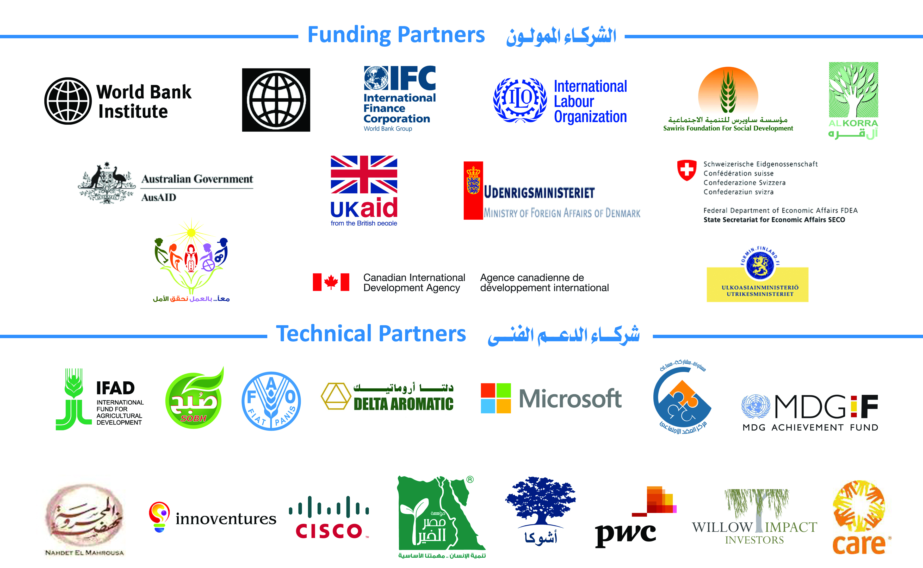**

***Deadline to Apply: December 24, 2012***

|  |  |  |  |
| --- | --- | --- | --- |
| 1. **ORGANIZATIONAL INFORMATION** | | | |
| **1** | Name of Organization: |  |  |
| **2** | Contact person: |  |  |
| **3** | Title (Dr., Mr., Mrs., Ms.) |  |  |
| **4** | Position within organization: |  |  |
| **5** | Phone number 1 (landline):  Phone number 2 (mobile): |  |  |
| **6** | Fax number: |  |  |
| **7** | E-mail address: |  |  |
| **8** | Website (if available): |  |  |
| **9** | Street address: |  |  |
| **10** | City/ Town/ Village: |  |  |
| **11** | Governorate: |  |  |
| **12** | Organization Type:  a) Company  b) NGO  c) Cooperative  d) Foundation  e) Not-for-profit Company  f) Other |  |  |
| **13** | Year of Establishment:  Registration Number: |  |  |
| **14** | **Organization History:** *Please describe the history of your organization and its mission statement.* *(Max. 300 words)* |  |  |
| **15** | Is your organization a woman owned or managed enterprise? | Yes  No |  |
| **16** | **Current Work:** *Please describe the current work of the organization – what functional and geographic areas are you active in and what is the current scope of operations? (Max. 300 words)* |  |  |
| **17** | **Leadership & Management Team:** *Please briefly describe your organization’s leadership team including details on the board and senior staff. Please provide details on – their background, reasons for founding the organization, description of the management style and leadership’s role in daily operations. You must be able to demonstrate commitment, necessary expertise as well as diversity on all levels including skills and backgrounds. (Max. 200 words)* |  |  |
| 1. **PROJECT DETAILS:** | | | |
| **18** | **Title of project:** |  |  |
| **19** | **Location of Implementation:** *Please specify geographic focus.* |  |  |
| **20** | **Problem definition:** *Please provide the context of the problem you aim to address. Wherever possible provide sources of data. (Max. 200 words)* |  |  |
| **21** | **Project:** *(Max. 500 words in total for all four sub-sections below)*   1. **Project Description:** *Please provide a brief description of the project. This is the section where you can highlight how you plan to scale-up and expand operations and activities to create more high quality jobs and expand activities, goods and services accessible to the poor.* 2. **Overall goal**:  *Please articulate a compelling vision of desired social outcomes highlighting the relationship between the project activities and the root cause of targeted social problems you are seeking to change.* 3. **Objectives:** *What do you aim to achieve with the project? Please include specific quantifiable and measurable targets that contribute to this goal, mentioned above.* 4. **Activities:** *Please outline specific actions that will help the project achieve those objectives listed above.* |  |  |
| **22** | **Target Group/Clients:**   * **Target group for employment:** *Please provide a profile for those you are targeting for job creation in terms of educational background, socio-economic background, gender, etc.* * **Client Description:** *Please provide a description of the market and a detailed profile of those you want to target as clients for your services, products and activities.* ***Note:*** *projects providing the poor with affordable high quality goods and services are more heavily weighted.* |  |  |
| **23** | **Current Social Impact:** *Please specify the organization’s positive social impact to date and where possible provide indicators on how such impact is being measured.* (*Max. 300 words)* |  |  |
| **24** | **Planned Social Impact:** *Please indicate how this grant will help you expand your social impact in the next two to three years. Wherever possible, provide indicators that will be used to measure this impact. (Max. 300 words)* |  |  |
| **25** | **Growth & Scale-up Potential:** *Please outline the unmet market demand projections and forecasted expansion for the products and services that you plan to offer. Where possible use data and evidence to support the claim that there is a sufficient market to warrant your social enterprise expansion. (Max. 300 words)* |  |  |
| **26** | **Leveraging Resources:** *Please specify how much, if any, resources you have secured or plan to raise beyond the resources generated by the grant whether through your own resources or contribution of financial or in-kind resources from other partners and stakeholders.* |  |  |
| **27** | **Organizational Needs:** *Based on your self-assessment, please describe your organization’s needs where technical assistance or peer learning could be helpful in building your organizational capacity to meet projected goals as you are scaling up.*   * *Financial management (please specify):* * *Business Planning (please specify):* * *Other management areas (please specify):* * *Other technical areas (related to agricultural supply chain or handicrafts):* |  |  |
| **28** | **Organizational Offers** *(Based on your self-assessment, please specify what you believe are your areas of strength that you might be able to* ***offer*** *to other DM winners, in case you get selected):*   * **Expertise:** *Please specify areas of expertise you could share with other winners.* * **Infrastructure:** *Technology, equipment, space, etc.* * **Others:** *Please specify.* |  |  |

**Project Timeline:**

*Please provide activity and shade the relevant months to show period expected for execution or the specific activity.*

|  |  |  |  |  |  |  |  |  |  |  |  |  |  |  |  |  |  |  |  |  |  |  |  |  |
| --- | --- | --- | --- | --- | --- | --- | --- | --- | --- | --- | --- | --- | --- | --- | --- | --- | --- | --- | --- | --- | --- | --- | --- | --- |
| **Year** | **2013** | | | | | | | | | | | | **2014** | | | | | | | | | | | |
| **Month** | **1** | **2** | **3** | **4** | **5** | **6** | **7** | **8** | **9** | **10** | **11** | **12** | **1** | **2** | **3** | **4** | **5** | **6** | **7** | **8** | **9** | **10** | **11** | **12** |
| **Activity 1:** |  |  |  |  |  |  |  |  |  |  |  |  |  |  |  |  |  |  |  |  |  |  |  |  |
| **Activity 2:** |  |  |  |  |  |  |  |  |  |  |  |  |  |  |  |  |  |  |  |  |  |  |  |  |
| **Activity 3:** |  |  |  |  |  |  |  |  |  |  |  |  |  |  |  |  |  |  |  |  |  |  |  |  |
|  |  |  |  |  |  |  |  |  |  |  |  |  |  |  |  |  |  |  |  |  |  |  |  |  |
|  |  |  |  |  |  |  |  |  |  |  |  |  |  |  |  |  |  |  |  |  |  |  |  |  |
|  |  |  |  |  |  |  |  |  |  |  |  |  |  |  |  |  |  |  |  |  |  |  |  |  |
|  |  |  |  |  |  |  |  |  |  |  |  |  |  |  |  |  |  |  |  |  |  |  |  |  |

1. **BUDGET:**

**Please note:**

* Please provide **budget notes** explaining briefly how the amounts presented below were reached. The following are suggested items. Please feel free only to fill out only the applicable items and to add others that might not be listed.
* The Egypt DM will provide a grant of no more than EGP150,000 (equivalent to USD25,000) for the entire project, distributed in two tranches over 24 months.
* You are encouraged to raise additional resources beyond those generated by the DM grant whether through your own resources or contribution of financial or in-kind resources from other partners and stakeholders.
* No more than 20% of the budget can be allocated to salaries (section 1 of budget template below). No more than 10% is to be allocated to Operating Costs (section 3 of budget template below).

**Project Budget (Years 1 and 2):**

|  |  |  |  |
| --- | --- | --- | --- |
|  | **Year 1** | **Year 2** | **Total** |
| **1. Project Staff Salaries** *(Planned New Hires/ Recruits):* | | | |
| Staff Salaries |  |  |  |
| Consultants |  |  |  |
| Other (if any) |  |  |  |
| **Sub-Total (EGP):** |  |  |  |
| **2. Travel & Transportation:** | | | |
| Staff Travel |  |  |  |
| Consultant Travel |  |  |  |
| Other (if any) |  |  |  |
| **Sub-Total (EGP):** |  |  |  |
| **3. Goods** *(Materials and Equipment)* | | | |
| Land |  |  |  |
| Equipment |  |  |  |
| Stock Inventory |  |  |  |
| Other (if any) |  |  |  |
| **Sub-Total (EGP):** |  |  |  |
| **4. Operating Costs:** | | | |
| Office rent |  |  |  |
| Administration & Accounting costs |  |  |  |
| Communication & Marketing |  |  |  |
| Technology (Hardware/software) |  |  |  |
| Other (if any) |  |  |  |
| **Sub-Total (EGP):** |  |  |  |
| **Other:** *(any other sections missing above such as Activities, etc)* |  |  |  |
| Other (if any) |  |  |  |
| **Sub-Total (EGP):** |  |  |  |
| **GRAND TOTAL (EGP):** |  |  |  |

**Financial Projections:**

|  |  |  |  |  |
| --- | --- | --- | --- | --- |
|  | **FY 2010/11** | **FY 2011/12** | **2012/13 (projected)** | **2013/14 (projected)** |
| **External Sources of funding as percentage from Annual Revenue** *(e.g.: donors’ funding, grants, if applicable)* |  |  |  |  |
| **Income-generated as a percentage from total annual revenue** *(includes activities, services, membership fees, etc).* |  |  |  |  |
|  | 100% | 100% | 100% | 100% |

1. **Required attachments (please attach the following documents with your application):**
2. Official registration papers of organization (NGO, Company or Cooperative, etc)
3. Financial Statement: copies of audited budgets (at least 1 year)
4. Detailed biographies and/or resumes of the founder and the management team.